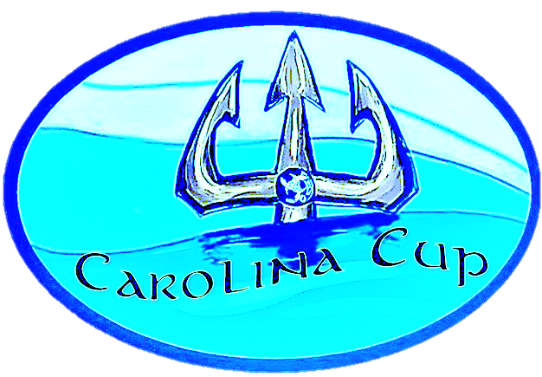

Carolina Cup
Parking Pass
Sept 11, 2021

Please Respect 25 mpr Speed Limit
All Parking at Soccer Field

