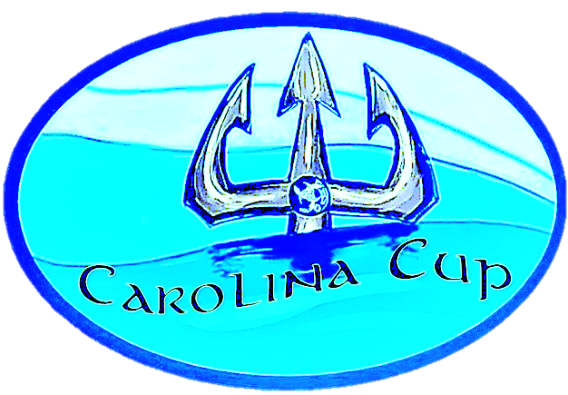

Carolina Cup
Parking Pass
Oct 10, 2020

Please Respect 25 mpr Speed Limit
All Parking at Soccer Field

