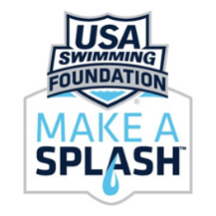
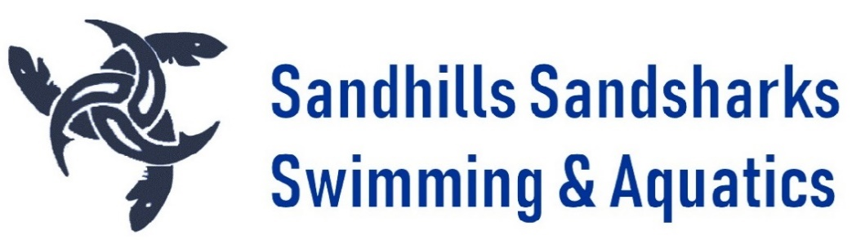

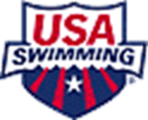

Dear Sponsors,
Sandhills Sandsharks, a non-profit (501c) organization, began in 1982 to bring lessons and competitive swimming to the Sandhills. Dedicated to developing swimmers of all ages and abilities and expanding aquatics programming in the Sandhills, the Sandsharks have proudly produced numerous State Champions, High School and Collegiate All-Americans and Scholastic-Swimming All-Americans. We support local high schools, Moore Buddies, Special Olympics, and the Boys & Girls Club. Our move to the Town of Southern Pines pool in June of 2018, and the winterization of the pool to include a heated bubble and locker rooms, have allowed us to expand our programming.
Your participation as a sponsor ensures continued aquatics programming in our community. Your leadership and support for USA Swimming in the Sandhills is greatly appreciated!
SSS’s aquatics programming includes:
- Make a Splash Foundation’s Learn to Swim program—Since joining Make A Splash two years ago, SSS has taught over 300 children, including 90 members of the Boys & Girls Club. Make a Splash targets underserved communities.
- Moore County Swim League—SSS manages the local summer league, comprised of seven teams and over 300 swimmers. Summer League gives many swimmers their first taste of competition in the pool.
- NC Open Water Champs & Carolina Cup Invitational—Open Water races at Lake Echo, drawing 700+ participants (plus families, bringing 1,500+ visitors to Moore County). The spring race is one of the largest amateur sporting events in Moore County. It’s Military Mile targets Tri-athletes, Master’s, and recreational swimmers —and benefits Moore County’s military children, through donations to the Student 2 Student program. The Poseidon race (5K, 3K, & 2K) challenges elite swimmers. The Carolina Cup in September, part of Open Water Select Camp for top North and South Carolina Swimmers includes 3K and 2K races, which are open to the public.
- Year Round and Flex Swim Competitive Swimming—The backbone of the Sandsharks, our year round program runs 48 weeks out of the year and provides top notch training for all ages of athletes; our senior squad consistently produces college level swimmers, while our youngest discover the joys of sportsmanship and thrill of competition. Flex Swim targets seasonal/multisport athletes meaning kids can keep one toe in the water while pursuing other activities.
Many sponsorships opportunities are available. Payment for sponsorships can be done through filling out this form. For more information on sponsorships/ donations, please contact Edward Hill at E.hill@lpl.com or Lindley Fleury at Lindley285@yahoo.com.

Thank you for supporting swimming in our community!
--The Sandhills Sandsharks Board of Directors

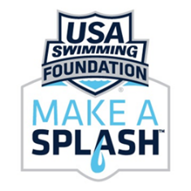
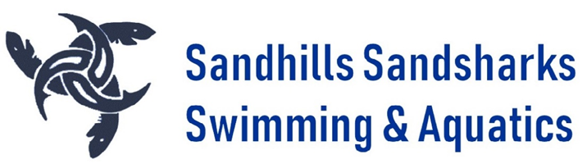

NC Open Water Championships Sponsorships
The Sandhills Sandsharks Swim Team is a 501c3 non-profit; all donations are tax deductible.

PLATINUM SPONSORSHIPS:
$3500: MAIN EVENT AND CAPS: Sponsorship and Swim Caps (1) OR
$2200: SWIM CAPS ONLY: Logo on one side of 700+ race caps (1 if above not taken)
$1600: MAIN EVENT ONLY: Logo on awards stand & top of Finish Line arch (1 if Main Event not taken)

RACE SPONSORSHIPS:
$1500: POSEIDON (5K/3K/2K Combined) (1)
$1000: 5K Male & Female*, 3K Male & Female*, 2K Male & Female* (3)
*single gender for 5K, 3K, 2K available for $500 each
$500: S2S Military Mile, 800 M, 400 M (3)

VENUE SPONSORSHIPS:
$500: Hospitality Tent, Pontoon Boat (2)
$300: Registration Tent Male or Female, Changing Tents, Male or Female (4)

Included for above sponsorships:
- Logo on website & T-Shirt
- Races only--Logo banner on race & winner’s stand, awards distribution, name announced throughout race.
- Venues only—Logo banner (Hosp tent/Pontoon) or Signs (Reg/Changing tents) on sponsored venue
- Breakfast, lunch, and refreshments throughout the event for SPONSOR’S Representative.

T-SHIRT and WEBSITE SPONSORSHIPS (Multiples)
$500 Level: WEBSITE Logo (exp 5/15 of next yr)
$300 Level: T-SHIRT Logo
$150 Level: T-SHIRT Line (name only)
__________________________________________________________________________________________
Sponsorship Level________________________________________________
Organization/Individual Name and Address: ________________________________________________________________
________________________________________________________________
Contact Name________________________ Phone number________________________
Email_______________________________Sandshark family point of contact ___________________________
Please remit payment to: Sandhills Sandsharks PO Box 657 Southern Pines, NC 28388

